Statistics

Statistics is the science of analysing data.

Types of data in statistics:

* Descriptive Statistics
* Inferential Statistics

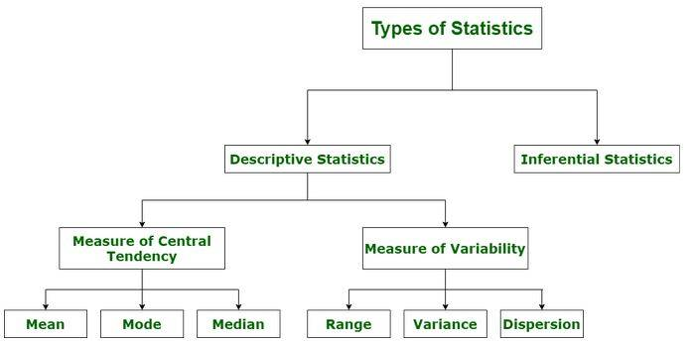

1. Descriptive Statistics

Descriptive statistics summarizes important features of a data set such as:

* Count
* Sum
* Standard Deviation
* Percentile
* Average
* Etc.. It is a good starting point to become familiar with the data.

We can use the describe() function in Python to summarize the data

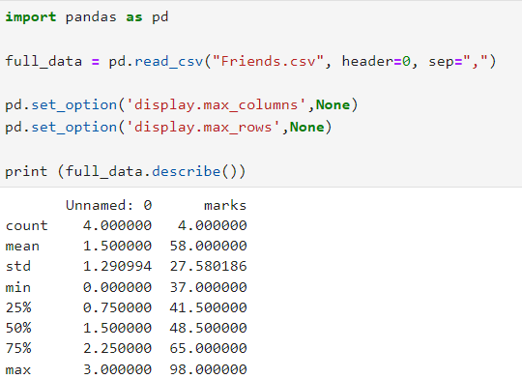

Inferential Statistics

This branch of statistics takes a random data sample from a portion of the population to make predictions, draw conclusions based on that information, and generalize the results to represent the data on-hand.

Four different methodologies or types:

* Parameter Estimation
* Confidence Intervals
* Regression Analysis
* Hypothesis Test

Population (N)

* + The population includes all members of a specified group.
  + Collecting data from an entire population can be time-consuming, expensive, and sometimes impractical or impossible.
  + Includes all residents in the city

Sample (n)

* A sample is a subset of the population.
* Samples offer a more feasible approach to studying populations, allowing researchers to draw conclusions based on smaller, manageable datasets.
* Consists of 1000 households, a subset of the entire population

Sampling Techniques

